CSC 205 Worksheet on Run-Time Analysis
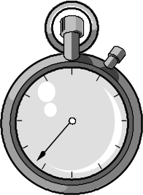
1. Suppose by careful measurement we have discovered a function that describes the
precise running time of some algorithm. For each of the following such
functions, describe the algorithmic running time in Big-O notation.

a. 3n² + 3n + 7
b. (5 * n) * (3 + log n)
c. (5n + 4) / 6

2. For each of the following program skeletons, describe the algorithmic execution time as a function of n using the Big-O Notation.

a. for (int i = 1; i <= 50; i++) {
......
}

b. for (int i = 1; i <= n; i++) {
for (int j = 1; j <= n; j++) {
. . . . .
}
}

c. for (int i = 1; i <= n; i++) {
. . . . . .
}
for (int j = n; j >= 1; j--) {
. . . . . .
}

d. for (int i = 1; i <= n; i++) {
for (int j = 1; j <= n; j++) {
for (int k = 1; k <= n; k++) {

}
}
}

3. Calculate the average number of checks you would need to make of an array of each of the following sizes using the linear and binary search algorithms :

- 16
- 64
c. 128

Run Time of Popular
Sorting and Searching Algorithms
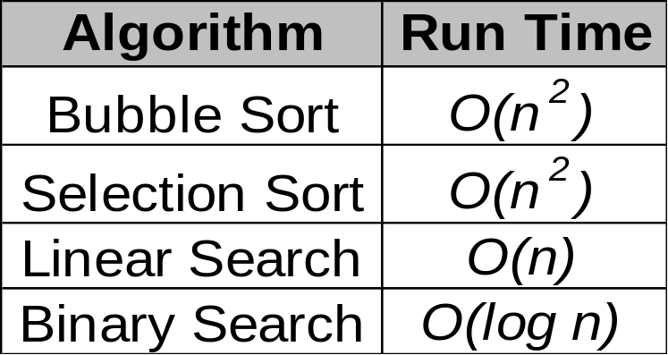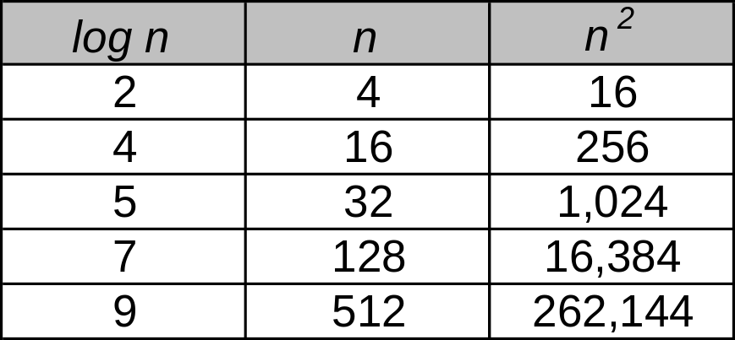
Changes in your input size n can make a BIG difference in the run time of your algorithm!

Answers to Run-Time Worksheet

1. a. O(n²)

b. O(n log n)

c. O(n)

2. a. This loop runs 50 times always. So, we have a constant run time which
we’ll express as O(n⁰) or O(1).

b. The outer loop of this loop runs n times, and the inner loop runs n times.
So, our total run time is O(n²).

c. Here we have two consecutive loops each of which runs n times. So, our we need to add their run times together which gives us 2n. Now, we need to take the term of the highest degree and factor out the constants. So, our total run time is O(n).

d. A triply-nested loop where each loop runs n times. So, we need to
multiply the run time of each which gives us a total run time of O(n³).

3. a. 4 checks using a binary search since the average run time is log n
8 checks using a linear search since the average run time is n/2

b. 6 checks using a binary search, 32 checks using a linear search

c. 7 checks using a binary search, 64 checks using a linear search

a. 3n² + 3n + 7

b. (5 * n) * (3 + log n)

c. (5n + 4) / 6

a. for (int i = 1; i <= 50; i++) {
......
}

b. for (int i = 1; i <= n; i++) {
for (int j = 1; j <= n; j++) {
. . . . .
}
}

c. for (int i = 1; i <= n; i++) {
. . . . . .
}
for (int j = n; j >= 1; j--) {
. . . . . .
}

d. for (int i = 1; i <= n; i++) {
for (int j = 1; j <= n; j++) {
for (int k = 1; k <= n; k++) {

}
}
}

